CS 6603: AI, Ethics, and Society

AI/ML - II Assignment

Cleo Zhang

yzhang3761@gatech.edu

***Abstract—***this assignment will continue to explore word embeddings and facial recognition applications using AI/ML algorithms. For Task Set #1, I will mainly tackle with Word2Vec, calculate the similarity measures, predict analogies and compute the related correlations, while in Task Set #2, the UTK dataset will be analyzed to evaluate the given algorithm.

# The task set #1

## Q1: Similarity Score for Each Word-target Pair

Using the target words *man* and *woman*, the similarity scores and rankings are listed in *Table 1.*

1. Similarity Score for Each Word-target Pair.

|  |  |  |  |  |
| --- | --- | --- | --- | --- |
| Target -  Man | Similarity Score | Target -  Woman | Similarity Score | Words ranked from the most similar to the least similar |
| man | 1.0 | woman | 1.0 | 1 |
| woman | 0.5876938 | child | 0.5898086 | 2 |
| child | 0.33342198 | man | 0.5876938 | 3 |
| doctor | 0.28924733 | husband | 0.44964314 | 4 |
| wife | 0.2834791 | birth | 0.42030883 | 5 |
| king | 0.26449704 | wife | 0.30068845 | 6 |
| husband | 0.23411639 | nurse | 0.25435835 | 7 |
| nurse | 0.153481 | queen | 0.22857243 | 8 |
| birth | 0.12343917 | teacher | 0.2040782 | 9 |
| scientist | 0.11226919 | doctor | 0.19613354 | 10 |
| queen | 0.110419504 | scientist | 0.13731061 | 11 |
| professor | 0.107622154 | king | 0.12252855 | 12 |
| teacher | 0.09874003 | professor | 0.10519859 | 13 |
| president | 0.09457928 | president | 0.084626846 | 14 |
| engineer | 0.087363556 | engineer | 0.044264372 | 15 |

## Q2: The Bigger Analogy Test Set (BATS)

### Similarity Scores for E10 [male - female].txt

This section selects *E10 [male - female].txt* from *BATS_3.0.zip* as an example, chooses the first word as the target word from each row and provides the measure of similarity between the target word and the other words on that row. See *Table 2* for details.

1. Similarity Measures for E10 [male - female].txt.

|  |  |  |
| --- | --- | --- |
| Targets | Paired Words | Similarity Score |
| actor | actress | 0.86941457 |
| batman | batwoman | N/A |
| boar | sow | 0.49044377 |
| boy | girl | 0.47565967 |
| brother | sister | 0.73543334 |
| buck | doe | 0.15203016 |
| bull | cow | 0.4411975 |
| businessman | businesswoman | 0.6755803 |
| chairman | chairwoman | N/A |
| dad | mom/mum | 0.74045944 |
| daddy | mommy/mother/mom | 0.42494774 |
| duke | duchess | 0.6362255 |
| emperor | empress | 0.66597676 |
| father | mother | 0.832764 |
| fisherman | fisherwoman | N/A |
| fox | vixen | 0.08036125 |
| gentleman | lady/gentlewoman/madam | 0.3554653 |
| god | goddess | 0.39541078 |
| grandfather | grandmother | 0.7366434 |
| grandpa | grandma | 0.55757904 |
| grandson | granddaughter | 0.6778581 |
| groom | bride | 0.3520856 |
| headmaster | headmistress | N/A |
| heir | heiress | 0.5088582 |
| hero | heroine | 0.46802154 |
| hound | bitch | 0.39353663 |
| husband | wife | 0.6377156 |
| king | queen | 0.5685571 |
| lion | lioness | N/A |
| man | woman | 0.5876938 |
| manager | manageress | N/A |
| mister | miss/missis/missus/mis'ess/mrs/ms/madam | 0.46928492 |
| murderer | murderess | N/A |
| nephew | niece | 0.73131126 |
| poet | poetess | 0.52189505 |
| policeman | policewoman | N/A |
| prince | princess | 0.72858447 |
| ram | ewe | 0.055268407 |
| rooster | hen | 0.29030108 |
| sculptor | sculptress | N/A |
| sir | madam | 0.22270176 |
| son | daughter | 0.7831376 |
| stallion | mare | 0.35898367 |
| stepfather | stepmother | 0.7483355 |
| superman | superwoman | N/A |
| tiger | tigress | 0.22913316 |
| uncle | aunt | 0.6715928 |
| valet | maid/maidservant/housemaid/chambermaid/handmaid/handmaiden/parlormaid/parlourmaid | 0.44579548 |
| waiter | waitress | 0.59829265 |
| webmaster | webmistress | N/A |

### Similarity Scores for words in E10 [male - female].txt and the protected class of Race (White, Black and Asian)

1. Similarity Measures for Targets from *E10 [male - female].txt* and subgroups of Race.

|  |  |  |  |
| --- | --- | --- | --- |
| Target words | Race | | |
| **White** | **Black** | **Asian** |
| **actor** | 0.112154886 | 0.117188476 | 0.13501917 |
| **batman** | 0.07052541s | 0.12345498 | 0.05379803 |
| **boar** | 0.25323373 | 0.25846544 | -0.009064786 |
| **boy** | 0.17648886 | 0.20971368 | 0.10126495 |
| **brother** | 0.009758618 | -0.0031859092 | -0.004879916 |
| **buck** | 0.189341 | 0.20390254 | 0.03470449 |
| **bull** | 0.30622458 | 0.21499804 | 0.064725064 |
| **businessman** | 0.00576384 | 0.014436396 | 0.032001123 |
| **chairman** | 0.042048324 | 0.056033432 | 0.07964939 |
| **dad** | 0.055559866 | 0.016293382 | -0.07342293 |
| **daddy** | 0.19687034 | 0.2812515 | -0.028832044 |
| **duke** | 0.022518612 | -0.016956175 | -0.039304893 |
| **emperor** | -0.01786165 | 0.0071171783 | 0.048299044 |
| **father** | 0.09366953 | 0.0655975 | -0.019721195 |
| **fisherman** | 0.117251284 | 0.19385749 | 0.035715796 |
| **fox** | 0.21393022 | 0.21027084 | 0.15807828 |
| **gentleman** | 0.10785405 | 0.0607187 | -0.07444218 |
| **god** | -0.025656916 | -0.03965547 | -0.06705533 |
| **grandfather** | 0.029033132 | 0.006285426 | 0.010667495 |
| **grandpa** | 0.04892783 | 0.09366512 | -0.0127419755 |
| **grandson** | -0.029455945 | -0.040287 | -0.12832639 |
| **groom** | 0.079278044 | 0.05671243 | -0.0760688 |
| **headmaster** | 0.017382141 | 0.020722328 | -0.1445562 |
| **heir** | -0.0408293 | -0.005706018 | -0.040426202 |
| **hero** | 0.07290649 | 0.09830141 | 0.021723844 |
| **hound** | 0.29115742 | 0.2606691 | 0.16440864 |
| **husband** | 0.037834864 | 0.02875693 | 0.018172387 |
| **king** | 0.06787935 | 0.05514486 | -0.043314025 |
| **lion** | 0.41088712 | 0.39581382 | 0.0828585 |
| **man** | 0.22502609 | 0.19195053 | 0.024129866 |
| **manager** | -0.02408023 | -0.015603832 | -0.0032726112 |
| **mister** | 0.19546364 | 0.17819811 | -0.12864235 |
| **murderer** | 0.08878327 | 0.11469219 | -0.11252994 |
| **nephew** | -0.061811276 | -0.09416974 | -0.102951765 |
| **poet** | 0.019909333 | 0.027736388 | 0.051442318 |
| **policeman** | 0.042711798 | 0.047845833 | -0.08623602 |
| **prince** | 0.086296335 | 0.09882948 | 0.008170075 |
| **ram** | -0.026666924 | -0.0712158 | -0.1618019 |
| **rooster** | 0.06210951 | 0.10439977 | -0.07390449 |
| **sculptor** | 0.019829215 | 0.030233975 | 0.061279375 |
| **sir** | 0.07660729 | 0.046330467 | -0.084699735 |
| **son** | -0.007016003 | -0.029756727 | -0.029293839 |
| **stallion** | 0.28766167 | 0.27896076 | 0.024622686 |
| **stepfather** | 0.01850353 | 0.011570036 | -0.16458844 |
| **superman** | 0.12685849 | 0.117827155 | 0.043981183 |
| **tiger** | 0.30093005 | 0.29617834 | 0.08696288 |
| **uncle** | 0.062507644 | 0.02548857 | -0.079233244 |
| **valet** | -0.043459445 | -0.013618459 | -0.16665865 |
| **waiter** | 0.09162004 | 0.08911913 | -0.07081734 |
| **webmaster** | -0.07853848 | -0.112115294 | -0.098304436 |

## Q3: Sentences

### My word analogies and similarity measures

*Table 4* shows the words I filled in to complete the sentence and the corresponding similarity score computed from it. “N/A” means the keyword is not present in the given model.

1. Complete the given sentences and compute the similarity between the pair of words.

|  |  |  |
| --- | --- | --- |
| Sentences | Words filled in the blank | Similarity Score |
| king is to throne as judge is to ___? | court | 0.6077864 |
| giant is to dwarf as genius is to ___? | idiot | 0.34426275 |
| college is to dean as jail is to ___? | jailor | N/A |
| arc is to circle as line is to ___? | triangle | 0.25559562 |
| French is to France as Dutch is to ___? | Netherlands | 0.41922885 |
| man is to woman as king is to ___? | queen | 0.5685571 |
| water is to ice as liquid is to ___? | solid | 0.6546474 |
| bad is to good as sad is to ___? | happy | 0.44885093 |
| nurse is to hospital as teacher is to ___? | school | 0.53265685 |
| usa is to pizza as japan is to ___? | sushi | 0.011866331 |
| human is to house as dog is to ___? | kennel | 0.28415978 |
| grass is to green as sky is to ___? | blue | 0.44396985 |
| video is to cassette as computer is to ____? | floppy disk | N/A |
| universe is to planet as house is to ____? | room | 0.25021723 |
| poverty is to wealth as sickness is to ___? | health | 0.19527602 |

### Analogies generated from Word2Vec

1. Complete the given sentences using Word2Vec and compute the similarity between the pair of words.

|  |  |  |
| --- | --- | --- |
| Sentences | Highest Similarity Score | Words filled in the blank |
| king is to throne as judge is to ___? | 0.5186458230018616 | prosecution |
| giant is to dwarf as genius is to ___? | 0.428088903427124 | theorist |
| college is to dean as jail is to ___? | 0.5444425344467163 | peress |
| arc is to circle as line is to ___? | 0.4287526309490204 | lines |
| French is to France as Dutch is to ___? | 0.6044681072235107 | netherlands |
| man is to woman as king is to ___? | 0.5532454252243042 | queen |
| water is to ice as liquid is to ___? | 0.4500039219856262 | solid |
| bad is to good as sad is to ___? | 0.4403817653656006 | glory |
| nurse is to hospital as teacher is to ___? | 0.48289814591407776 | institution |
| usa is to pizza as japan is to ___? | 0.576350748538971 | dishes |
| human is to house as dog is to ___? | 0.4231664538383484 | hound |
| grass is to green as sky is to ___? | 0.5478643178939819 | blue |
| video is to cassette as computer is to ____? | 0.6654506921768188 | peripherals |
| universe is to planet as house is to ____? | 0.42647024989128113 | houses |
| poverty is to wealth as sickness is to ___? | 0.49606096744537354 | impious |

### Correlation between the vector of similarity scores from your analogies versus the Word2Vec analogy-generated similarity scores

1. The correlation of the analogies' vector of similarity scores versus the Word2Vec analogy-generated similarity scores.

|  |  |
| --- | --- |
| Correlation Coefficient | Strength of the correlation |
| 0.01904545 | “very weak” correlation |

# Task set #2

## Frequency Tables

Frequency tables of images associated with age, gender and race are summarized in *Figure 1*, and we can conclude that:

* For age, the subgroup (0-20) has the most significant representation while (81-116) has the least.
* For gender, the female subgroup (1) has the largest representation, while the male (0) has the least representation.
* For race, the subgroup of white (0) has the largest representation, while Black (1) has the least.

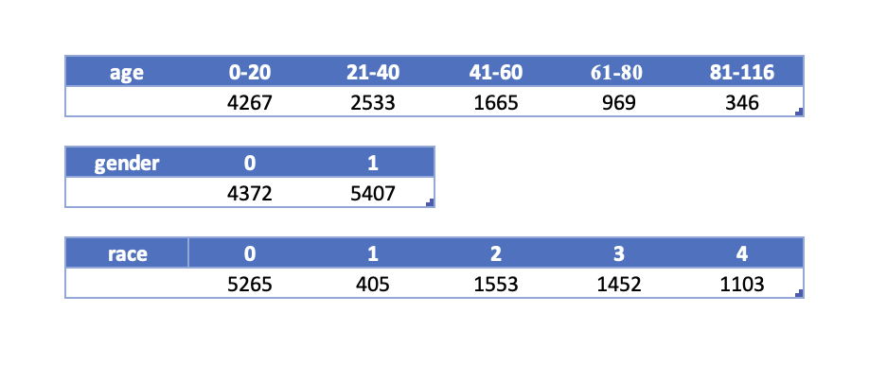

1. Frequency of images associated with each subgroup for age, gender and race.

*Figure 2* shows the entire distribution of the UTK dataset subgroups.

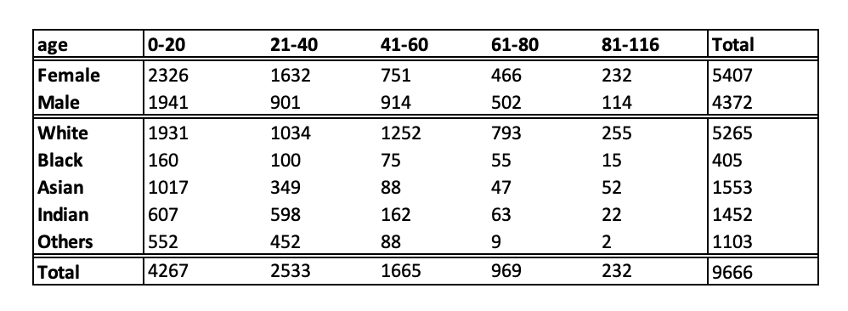

***Figure 2 -*** Full distribution of the UTK dataset.

## Mostly Heavily Impacted Group

According to Figure 2, the total sample size is 9666, and the “others” race aged 81-116 takes the least representation (about 0.0207% of the sample). Therefore, if an algorithm is trained based on this dataset, the “others” race aged 81-116 will be impacted the most as the data is lacking in this group. The trained algorithm is likely to reinforce the existing stereotypes or discrimination against this minority of the population.